**Mohammed Al Madhi**

**Assignment 7: A review of chapters 1 to 5**

**CIS 310 FALL 2019**

**Please do your best to answer the following six questions, using Visio or Lucid Chart.**

**1. Typically, a patient staying in a hospital receives medications that have been ordered by a particular doctor. Because the patient often receives several medications per day, there is a 1:M relationship between PATIENT and ORDER. Similarly, each order can include several medications, creating a 1:M relationship between ORDER and MEDICATION.**

1. **Identify the business rules for PATIENT, ORDER, and MEDICATION.**

* **A PATIENT is allowed to have MANY medicaiations orders for him/her**
* **Each medication order is only written for a single pateint**

**ORDER Entitiy**

* **Each order can have many medications**
* **Each medication can be prescribed in many orders**

**MEDICATION**

* **Medication can be prescribed in many orders**
* **And medical orders can prescribe many medications**

**b. Create a Crow's Foot ERD that depicts a relational database model to capture these business rules.**

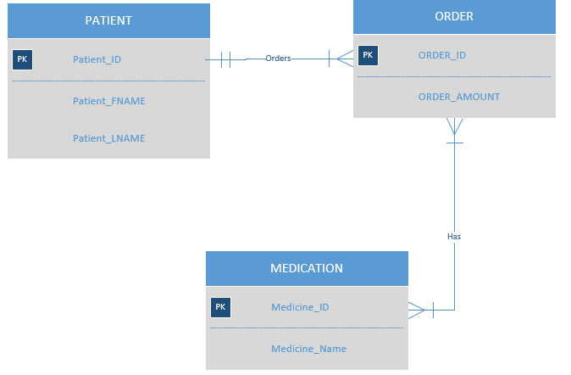

**2. United Broke Artists (UBA) is a broker for not-so-famous painters. UBA maintains a small network database to track painters, paintings, and galleries. A painting is painted by a particular artist, and that painting is exhibited in a particular gallery. A gallery can exhibit many paintings, but each painting can be exhibited in only one gallery. Similarly, a painting is painted by a single painter, but each painter can paint many paintings. Using PAINTER, PAINTING, and GALLERY, in terms of a relational database:**

1. **What tables would you create, and what would the table components be? Identify each table with attributes**



1. **Identify applicable business rules for each entities (tables)**

* **Painter paints many paintings**
* **A painining is painted by only one painter**
* **Gallery can have many paintings**
* **Painter can have many paintings in gallery**

1. **Show the relationships in a Crow’s Foot diagram**

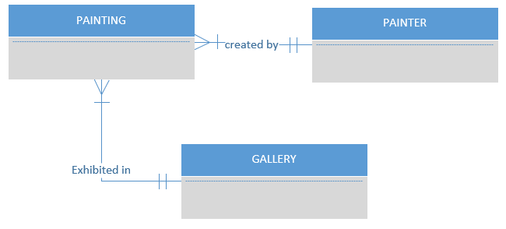

**3. Using the ERD you created from Problem 2, create the relational diagram. (Create an appropriate collection of attributes for each of the entities. Make sure you use the appropriate naming conventions to name the attributes.)**

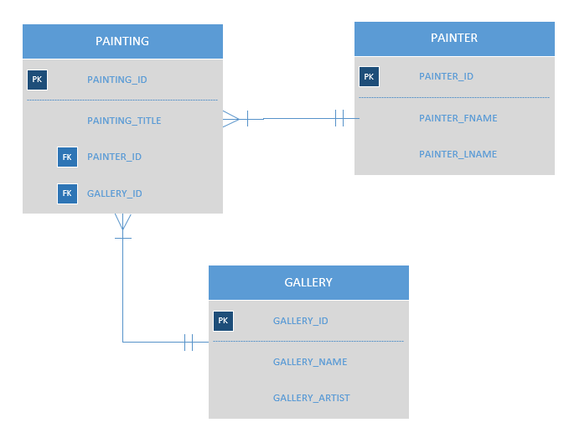

**4. Convert the ERD from Problem 1 into the corresponding UML class diagram.**

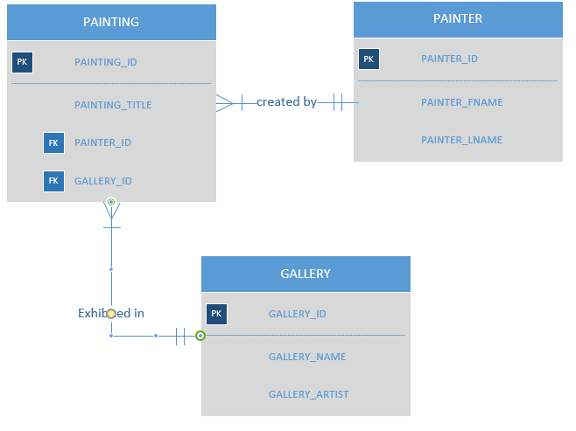

**5. Identify the business rules from the depicted relationships in the Crow’s Foot ERD shown in Figure 5.1**

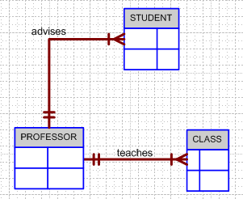

One and only professor teaches many one to many classes

A class is tought by one professor

One and only professor advises one to many students

**Figure 5.1 The Crow’s Foot ERD for Problem 5**

**6. Create a Crow’s Foot ERD to include the following business rules for the ProdCo company:**

1. **Each sales representative writes many invoices.**
2. **Each invoice is written by one sales representative.**
3. **Each sales representative is assigned to one department.**
4. **Each department has many sales representatives.**
5. **Each customer can generate many invoices.**
6. **Each invoice is generated by one customer.**

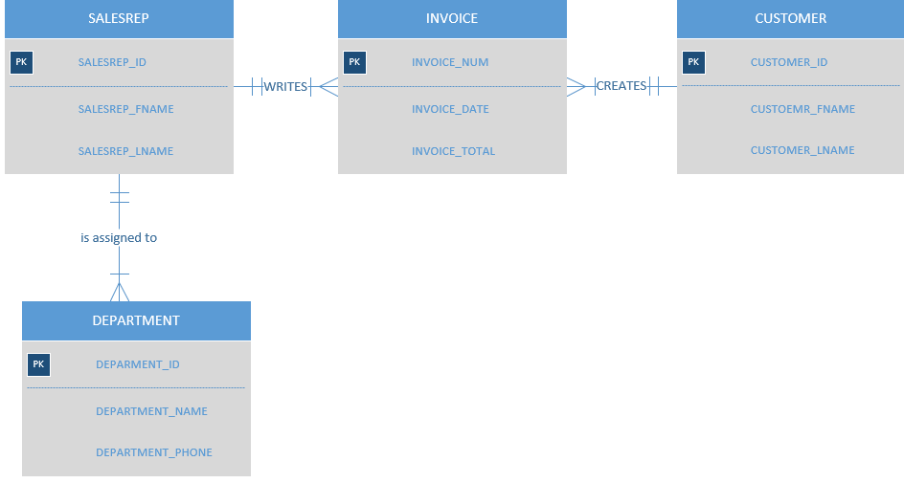

**7. What is normalization and why it’s important?**

**Data Normalization is database design techique that creates an organized tables that reduces reduces redundancy and dependency of data. It is important because it helps with the speed, accuracy, and efficiency of the database.**

**a. describe the three forms**

**There are three common forms of database normalization: 1st, 2nd, and 3rd normal form. They are also known as 1NF, 2NF and 3NF.**

**First Normal Form (1NF): the rule states that an attribute (column) of table should hld only atomic value which means it cannot hold multiple values.**

**Second Normal Form(2NF): includes 1NF First normal form and is no non-prime attribute is dependent on the proper subset of any candidate key of table**

**Third Normal Form(3NF): when it is in 2NF and when all of its attributes are directly dependent on the primary key**

1. **describe the data modeling checklist**

**Data modeling serves as a bridge between real-world objects and the database model that is implemented in the computer**

**Data Modling include: Entity names, Attribute names, Relationship names and Entities**